|  |
| --- |
| **3. SIGNAL ANALYSIS** |

3.1. **Wave Analyzers**

- Basic/Resonant Wave Analyzer

- Frequency selective Wave Analyzer

- Heterodyne Wave Analyzer

3.2. **Harmonic Distortion Analyzers**

- using Resonant Bridge

- using Wien Bridge

- using Bridge T- Network

3.3. **Harmonic Distortion Analyzers**

- Filter bank Spectrum Analyzer

- Using Swept Receiver Design

- Super heterodyne / RF Spectrum Analyzer

3.4. **FFT Analyzer / Digital Fourier Analyzer**

3.5. **Logic Analyzer**

|  |
| --- |
| **3.1. WAVE ANALYZERS** |

***Definition:***

* It can be shown mathematically that any complex waveform is made up of a fundamental and its harmonics.
* Wave Analyzers are used to measure the magnitude of each harmonic (or) fundamental separately.
* Basically a wave analyzer is a frequency selective voltmeter which is tuned to a frequency of one signal component while rejecting all other signal components.
* The wave analyzers indicate the amplitude of single frequency component within a range of 10Hz to 40MHz.

***Applications:***

* To carry out complete harmonic analysis.
* To measure relative amplitudes of single frequency components in a complex waveform.
* Used for electrical measurements, sound, vibration, noise measurements in industries.

***Types of Wave analyzers:***

1. Basic/Resonant Wave analyzer
2. Frequency selective analyzer
3. Heterodyne wave analyzer

**3.1(a) Basic Wave Analyzer:**

*Common 🡪 Define wave analyzer, give types & write applications.*

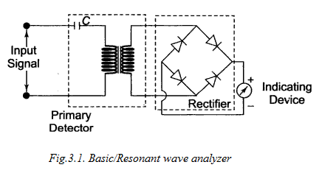

The basic wave analyzer consists of Primary detector, FWR and Indicator.

***Primary detector***

* It is a simple LC circuit.
* This LC circuit is adjusted for resonance at the frequency of particular harmonic component to be measured.
* Since LC circuit is tuned to a single frequency, it passes only the frequency to which it is tuned and rejects all other frequencies.

***Full Wave Rectifier***

To obtain the average value of the input signal.

**Indicator**

* It is a DC Voltmeter that is calibrated to read the peak value of the sinusoidal input voltage.
* A no.of tuned filters, connected to indicating device through a selector switch would

be repaired for a useful wave analyzer.

**3.1(b) *Frequency Selective Wave Analyzer*:**

* This wave analyzer is used for measurements in the AF range i.e. from 20Hz to 20 KHz.
* It consists of a very narrow band pass filter section that can be turned to a particular frequency.

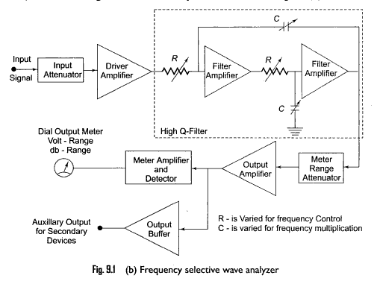

***Operation:***

* The complex waveform to be analyzer is passed through an adjustable attenuator which serves as a range multiplier; so that large range of signal amplitudes can be analyzed without loading the amplifier.
* The attenuated o/p is applied to a high Q-active filter through driver amplifier.
* The high Q-filter transmits the selected frequency& rejects all other frequencies. The filter circuit consists of cascaded RC resonant circuit and amplifiers. Capacitors are used for selecting the frequency range and precision potentiometers are used to tune the filter to any desired frequency within the selected band. The entire AF range is covered in decade steps by switching the capacitors in the RC sector.
* The selected signal o/p from the final amplifier stage is applied to the meter circuit and untuned buffer amplifier. The buffer amplifier is used to drive o/p devices such as recorders (or) electronic counters.
* The meter is calibrated in Volts & dBs to indicate the magnitude of selected frequency component.

**Note:**

1. The wave analyzer should have extremely low i/p distortion, undetectable by the analyzer itself.
2. The BW of the instrument is very narrow typically about 1% of selected frequency.

**3.1(c) *Heterodyne Wave Analyzer***

The heterodyne wave analyzers are designed for measurements in RF range and above MHz range. Its operation depends on the principle of heterodyning (or) mixing.

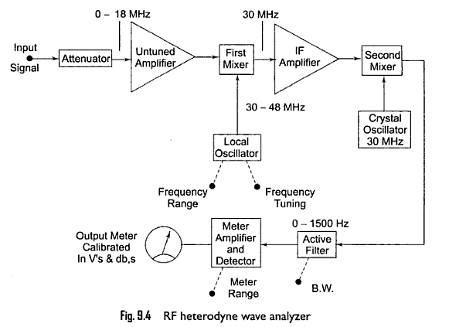

***Operation:***

* The input signal to be analyzed is applied through an attenuator and untuned amplifier.
* The o/p of amplifier is heterodyned in the First Mixer stage with the signal from local oscillator having frequency of 30-48MHz.
* The first stage mixer produces an o/p signal which is the difference of flocal and i/p signal to produce an IF signal of 30MHz.
* This IF signal is uniformly amplified by the IF amplifier.
* The amplitude of IF signal is fed to the second mixer stage, where it is again heterodyned to produce a difference frequency (or) IF of zero frequency.
* The selected component is then passed to the meter amplifier & detector through an active filter having a controlled BW. The meter is calibrated in volts &dbs to indicate the magnitude of selected component.
* This wave analyzer is operated in the RF range of 10KHZ to 18MHZ with 18 overlapping bands selected by frequency range control of local oscillator.

|  |
| --- |
| **3.2. HARMONIC DISTORTION - INTRODUCTION** |

***What is distortion***: Distortion refers to the deviation in any parameter like amplitude, frequency, phase of a signal from that of an ideal signal.

**How distortion occurs**: Distortion may be introduced in a signal when it is transmitted from

one point to other point through a transmission channel. The transmission channel consists of various electronic components like amplifier, heterodyning element etc.

When a sinusoidal signal is applied to an electronic circuit, it produce a sinusoidal output.

But the output waveform is not exact replica of the input wave form because of various types of distortion may occur due to non-linear characteristics of different component used in electronic circuit. These non-linear behavior circuit elements introduce harmonics of fundamental frequencies in the o/p signal and the resultant distortion is called as harmonic distortion.

Harmonic components occur at frequencies 2f1, 3f1, 4f1 ,……… where f1 is the fundamental frequency of the signal. The total harmonic distortion (or) distortion factor is given by

D = $\sqrt{D_{2}^{2 }+D_{3}^{2 }+D_{4}^{2 }+ ……….}$

The distortion of particular harmonic is given by

D2 = ; D3 = ; ………. Dn = ;

where *Dn= distortion due to nth harmonic*

*En= amplitude of n th harmonic*

*E1= amplitude of fundamental*

Total Harmonic Distortion (THD) = $\frac{\sqrt{E_{2}^{2 }+E_{3}^{2 }+E_{4}^{2 }+ ……….}}{E_{1}}$

***The different types of distortions caused by an electronic circuit are***

* Amplitude distortion
* Frequency distortion
* Phase distortion/delay distortion
* Cross over distortion
* Inter modulation distortion
* Amplitude distortion

**(1). Amplitude distortion**: When the amplitude of o/p signal is not a linear function of the amplitude of the amplitude of the i/p signal under specific conditions, then such type of distortion is called as Amplitude Distortion. AD occurs when Amplifier circuit introduces harmonics of fundamental frequency

**(2) Frequency distortion**: It takes place when the signal is amplified by different amounts at different frequencies. It is mainly due to the combination of active & passive components in circuit.

Ex: Non-uniform frequency response of RC coupled amplifier

**(3) Phase distortion/delay distortion**: If the phase of the o/p signal is different from the phase of

the i/p signal then such type of distortion is called as phase distortion.

The P.D occurs due to the presence of energy storage elements in the circuit.

P.D leads to delay in the transmission of a signal. Hence it is also called as delay distortion.

The phase shifts may be different at different frequency (or) it may be same.

**(4) Cross over distortion:** The improper biasing voltages of electronic

components of an amplifier produce C.O.D as shown in figure.

**(5) Inter modulation distortion**: When two signals of different frequencies are mixed together (i.e., heterodyned) the resultant signal will be the sum (or) difference of actual frequencies of signals. i.e., f1±f2, 2f1±f2, 3f1±f3 , 4f1±f2 ……...etc. Thus when the signals are heterodyned, additional frequency components are generated which are undesirable and lead to distortion in the signal. The distortion caused by heterodyning of frequencies is called IMD.

**HARMONIC DISTORTION ANALYZER:**

* The various distortions in the signal can be analyzed by using a distortion analyzer.
* The harmonic distortion analyzer (HAD) measures T.H.D without indicating the amplitude & frequency of each component.
* To measure THD, the i/p signal is passed through a narrow band reject filter whose cut-off frequency is the fundamental frequency (or) a HPF whose cut-off frequency is a little above the fundamental frequency.
* This filter suppresses (or) rejects the fundamental frequency & transmits all the harmonics for subsequent measurements. This method of measuring THD is called as fundamental suppression type & it uses a bridge circuit to reject the fundamental frequency.

***Applications of H.D.A:***

* It is used to measure THD of a signal
* It can be used to analyze the fundamental wave and its harmonics.
* It is used in design & development of audio circuits.
* It is used in analog & digital circuits to measure distortion due to different components

employed in the circuit.

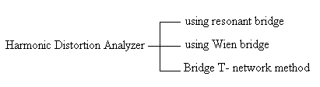

**(1) Using a resonant bridge**:

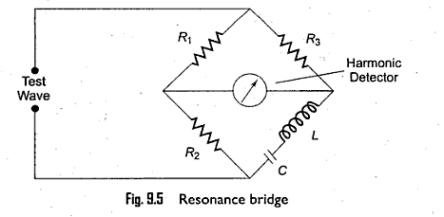

* In the bridge circuit shown in figure, the circuit is tuned to fundamental frequency and hence the bridge is balanced for fundamental frequency.
* The bridge is unbalanced for the harmonics i.e., only harmonic power will be available at the o/p terminal and that can be measured.
* If the fundamental frequency is changed, the bridge must be balance again.
* If L & C are fixed components then this method is suitable for a test wave with fixed freq.

When a continuous adjustment of the fundamental frequency is desired, a Wien bridge

arrangement is used as shown in figure.

**(2) Using Wien bridge:**

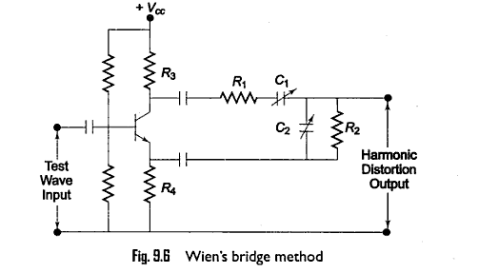

* The Wien bridge circuit is used as rejection filter for the fundamental frequency of input signal.
* The bridge is tuned to fundamental frequency and balanced for zero output by setting

R1 R2 C1 & C2.

* When the bridge is tuned & balanced for fundamental frequency , the output will be zero for the frequency. For all other frequencies, the Wien bridge offers varying degrees of phase shift & attenuation and the distortion output can be measured with a meter.

**(3) Bridged T- Network:**

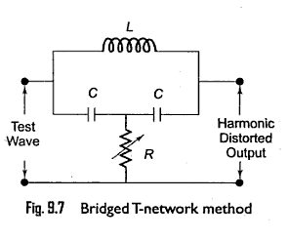

* The briged T-network shown in above figure is tuned to fundamental frequency of input signal. Hence it rejects the fundamental components & transmits only harmonic components to the o/p terminals and this distorted output can be measured by output meter.
* For better performance, Q-factor of the resonant circuit must be high.
* The way of using bridge T-network is given in fig(9.8).

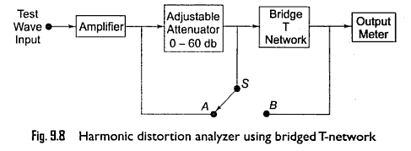

* First the switch is connected to position(1) so that attenuator is not included in the circuit.
* Now bridge T- network is adjusted to suppress the total fundamental frequency.(min. output).
* The min-o/p indicates that the bridge T- network is turned to the fundamental frequency .
* The switch is next connected to position(2) so that the bridge T- network is not included in ckt.
* Now adjustable attenuator is varied until the same reading is obtained on the o/p meter.

At this condition, the attenuator reading gives the total RMS distortion.

* The harmonic distortion analyzer based on fundamental suppression principle is easy to design & less cost than wave analyzer. The disadvantages are that they will give only total distortion & will not give the amplitude of individual distortion components.

|  |
| --- |
| **3.3. SPECTRUM ANALYZERS** |

* Spectrum analyzer is an instrument designed to provide graphical display of the spectrum of frequencies on the CRT with *frequency on the horizontal axis* & *amplitude on the vertical axis*.
* In the case of normal oscilloscope, the signal is plotted as a function of time *i,e Amplitude Vs Time*. Such analysis is called as time domain analysis. In the case of spectrum analyzer, the signal is plotted as function of frequency. This analysis is called as frequency domain analysis
* The spectrum analyzer displays vertical lines against X & Y co-ordinates, which represent the magnitude of sinusoidal components and horizontal location represents the frequency.
* These instruments provide a display of the frequency spectrum over a given frequency band.
* The spectrum analysis of a signal provides the information about
* Band width
* Effects of different types of modulation
* Frequency stability
* The components levels
* Spectral purity
* Attenuation
* **TYPES OF SPECTRUM ANALYZERS**

1. Filter bank Spectrum analyzer
2. Spectrum analyzer using Swept receiver design
3. Super heterodyne spectrum analyzer (RF Spectrum analyzer)

**3.3 (a). Filter bank Spectrum analyzer :**

*Common 🡪 Define S.A. , write advantages & give types of S.A.*

* In a parallel filter bank analyzer, the frequency range is covered by a series of filters whose central frequency & bandwidth are so selected that they overlap each other as shown in fig.
* The parallel filter bank spectrum analyzer uses N- number of filter and each filter tuned to different frequency. Each filter removes all frequency components of the signal, except the particular frequency that the filter was designed to measure.
* The outputs of filters are detected and displayed to the CRO to produce the frequency domain representation

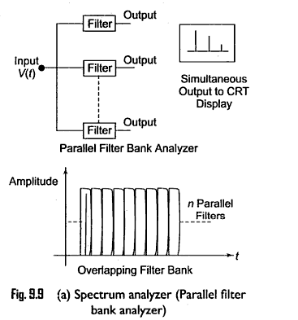

* In a parallel filter bank analyzer, the frequency resolution of bank of filters depends on the bandwidth of individual filters. The filter should have high Q-factor.
* By increasing the number of filters, we can increase frequency range & frequency resolution. This method is not suitable for wide BW measurement.

**3.3 (b). Spectrum analyzer using Swept receiver design :**

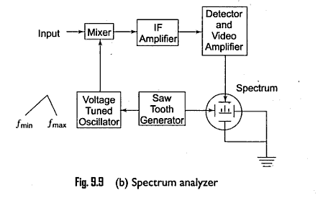

* The input signal to be tested is applied to mixer
* The saw tooth generator provides saw tooth voltage signal to the horizontal deflection plates of CRO and to Voltage Turned Oscillator (VTO).
* The VTO then sweeps from *fmin to fmax*of its frequency band at a liner rate and beats with input signal frequency component to produce an IF. This IF component is produced whenever a freq. component is present during the sweep.

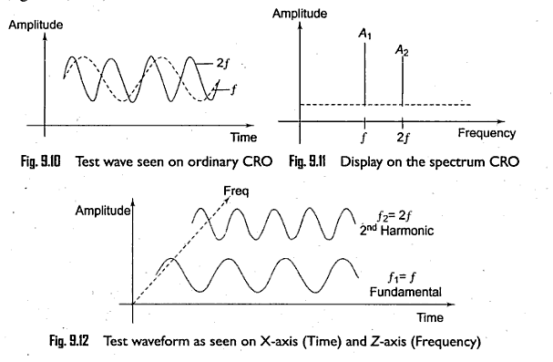

* The resulting IF components are filtered & amplified by IF amplifier and rectified by detector circuit. This detected signal is then applied to Vertical deflection plates of CRO to produce a display of amplitude Vs frequency on CRT screen.
* As VTO frequency sweeps, the amplitude of different frequency components appear on the screen one by one separated from each other in horizontal direction.
* The frequency range covered by this instruments is from 1 to 40 GHz

**3.3 (c). RF / Super heterodyne Spectrum analyzer :**

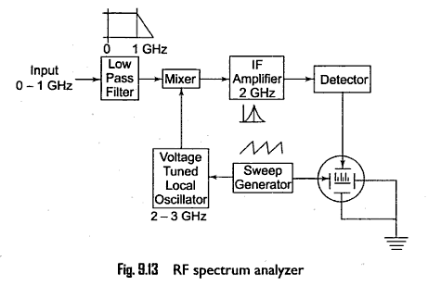

* For the study of RF spectrum produced in micro wave instruments, a narrow band super heterodyne spectrum analyzer is used. It covers the frequency range from 500KHZ to 1GHZ.
* The low pass filter removes the frequency components above 1GHZ.
* The o/p of LPF is fed to a MIXER which is driven by a voltage tuned local oscillator (2-3GHZ)
* The mixer produces two signals at its o/p whose amplitudes are proportional the i/p signal but their frequencies are sum & difference of input signal & local oscillator frequency.
* The IF signal is tuned to a narrow band around 2GHZ .
* The IF signal is amplified by IF signal reached by detector. This detected signal is then then applied to vertical deflection plates of CRO to produce a display of amplitude VS frequency on CRT.
* As saw tooth signal sweeps, the local oscillator sweeps linearly for 2-3 GHZ and hence the spectrum of 0-1GHZ is displayed on CRT.

**Applications of Spectrum analyzers:**

* Spectrum analyzer is an instrument designed to provide graphical display of the spectrum of frequencies on the CRT with *frequency on the horizontal axis* & *amplitude on the vertical axis*.
* In the case of normal oscilloscope, the signal is plotted as a function of time *i,e Amplitude Vs Time*. Such analysis is called as time domain analysis. In the case of spectrum analyzer, the signal is plotted as function of frequency. This analysis is called as frequency domain analysis
* The spectrum analyzer displays vertical lines against X & Y co-ordinates, which represent the magnitude of sinusoidal components and horizontal location represents the frequency.
* These instruments provide a display of the frequency spectrum over a given frequency band.
* The spectrum analysis of a signal provides the information about
* Band width
* Effects of different types of modulation
* Frequency stability
* The components levels
* Spectral purity
* Attenuation
* **Some examples of signals that are applied to the** Spectrum analyzer **to observe the spectrum are**

1. **Pure sinusoid with no harmonic distortion**
2. **Amplitude modulation**
3. **Frequency modulation**
4. **Pulse modulation**
5. **Harmonic Distortion**
6. **Bio-medical & radar signal analysis.**

**Characteristics of Spectrum analyzer :**

**(i) Sensitivity: It is the ability of Spectrum** analyzer **to detect small signals. In case of**

**measurement of low level modulation, the sensitivity of spectrum analyzer is very useful.**

**(ii) Dynamic range: It is the ability of Spectrum** analyzer **to display and detect small and large**

**signals simultaneously.**

**(iii) Frequency resolution: It is the ability of Spectrum** analyzer **to separate the signals which are**

**closely spaced in the frequency. It depends on bandwidth and sensitivity of IF amplifier.**

**(iv) Harmonic mixing: The frequency range of Spectrum** analyzer **is increased with harmonic**

**mixing. The function of MIXER is to mix the input signal frequency with fundamental frequency of Voltage tuned oscillator. Usually at input stage of Spectrum** analyzer, **a LPF is used to remove High frequency components. But if we place a BPF instead of LPF, it extends the frequency range of the Spectrum** analyzer.

|  |
| --- |
| **3.4. DIGITAL FOURIER ANALYZER /** . . **FFT SPECTRUM ANALYZER** |

* **In real time Spectrum analyzer, the signal is analyzed by band pass filtering, notch filtering, frequency translation and various combinations of these techniques.**
* **The Digital Fourier analyzers are based on the calculations of discrete Fourier Transform by using an algorithm. This algorithm calculates the amplitude & phase of each signal component from a set of time-domain samples of input signal.**
* **FFT is very efficient mathematical technique for computing the spectrum of a waveform from its time domain samples.**
* **First the analog waveform is sampled and turned into digital form by using appropriate method of A/D conversion. The ratio at which the sampling occurs is called as sampling rate.**
* **According to sampling theorem, the sampling should be done at** Nyquist rate to preserve the information of the signal.

i.e., from sampling theorem, *fs = 2fm*

*where fs = sampling frequency*

*fm = Max. freq. component of the signal*.

* **The LPF is used to eliminate the frequencies greater than** *fm* to ensure that the sampling theorem is satisfied.
* The result of A/D conversion is a set of digital numbers, representing the amplitudes of the input waveform as a function of time over a specific period of time.
* These set of samples are called as *time record* and stored in RAM.
* The FFT processor then performs the desired series of calculations on *time record* to obtain the frequency domain results. These results can be displayed on CRT.

**Comparison between Wave analyzer & Harmonic Distortion Analyzer :**

